**CP5046 ICT PROJECT 1 - ASSESSMENT TASK 2**

**PROJECT DOCUMENTATION**

**Team Number :** 5

**Group Member:** Xuan Hai Nguyen (12885170)

Gagandeep Singh (1312630)

Rajbir kaur gill (12864385)

 Anay Gharat (13131701)

**Lecturer Name:** Laura Antochi

Prototypes

Prototypes are demonstrated to justify the proposed Alpha-Release.

1. Home Page

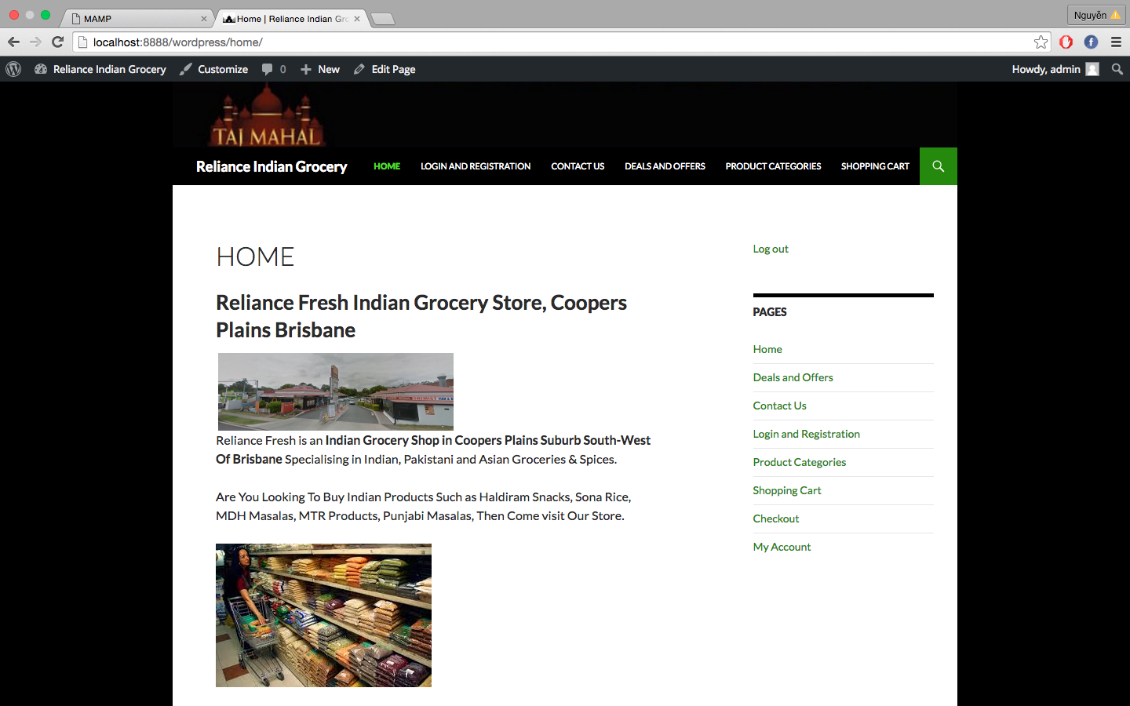

1. Registration Pages

After the User register is successful, the information of the user will be stored in the database and accept user to login automatically.

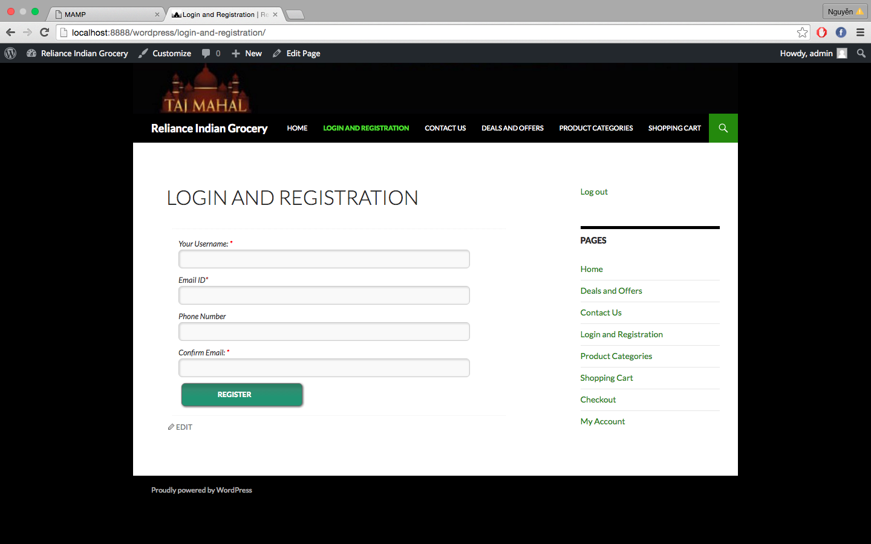

1. Contact Us page

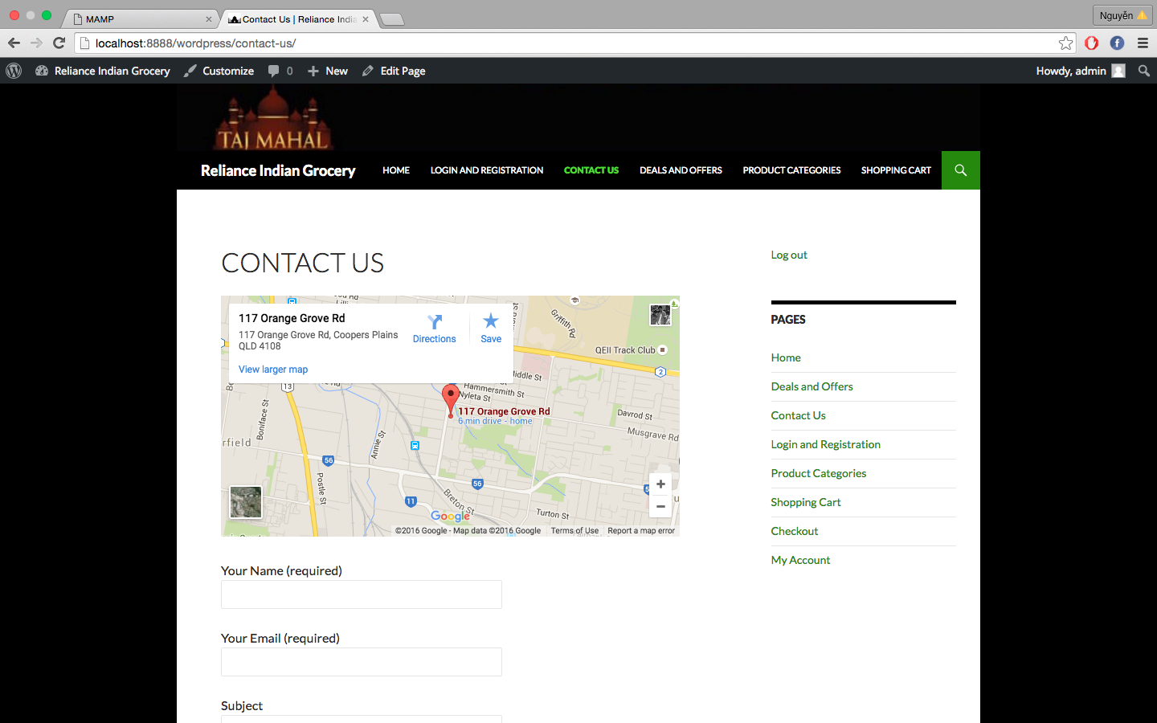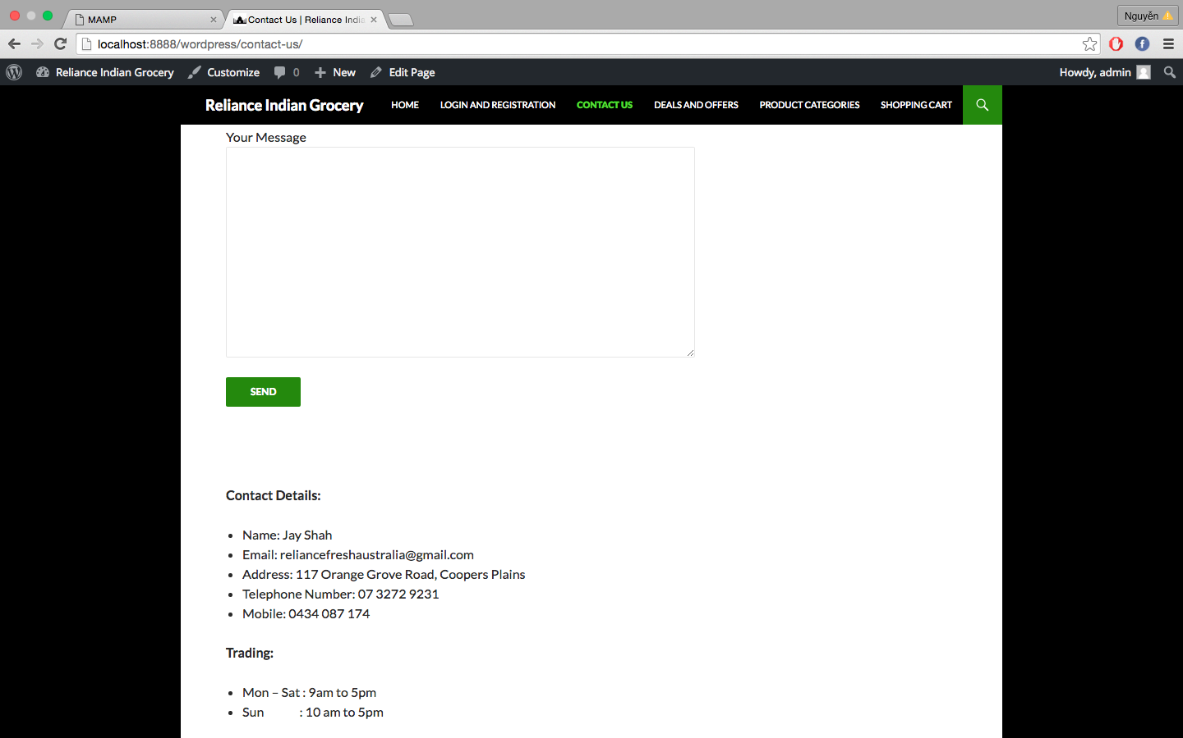

1. Product Categories page

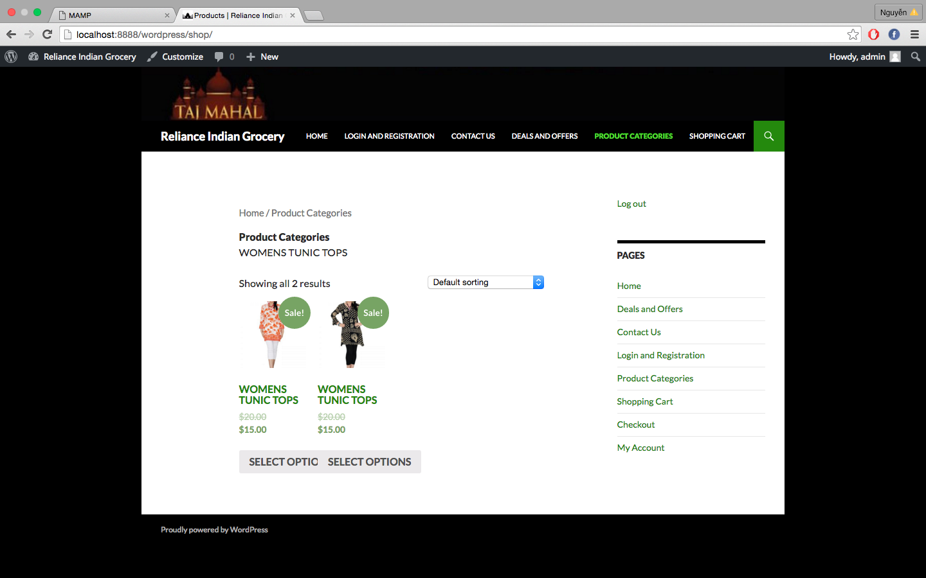

1. Deals and Offers page

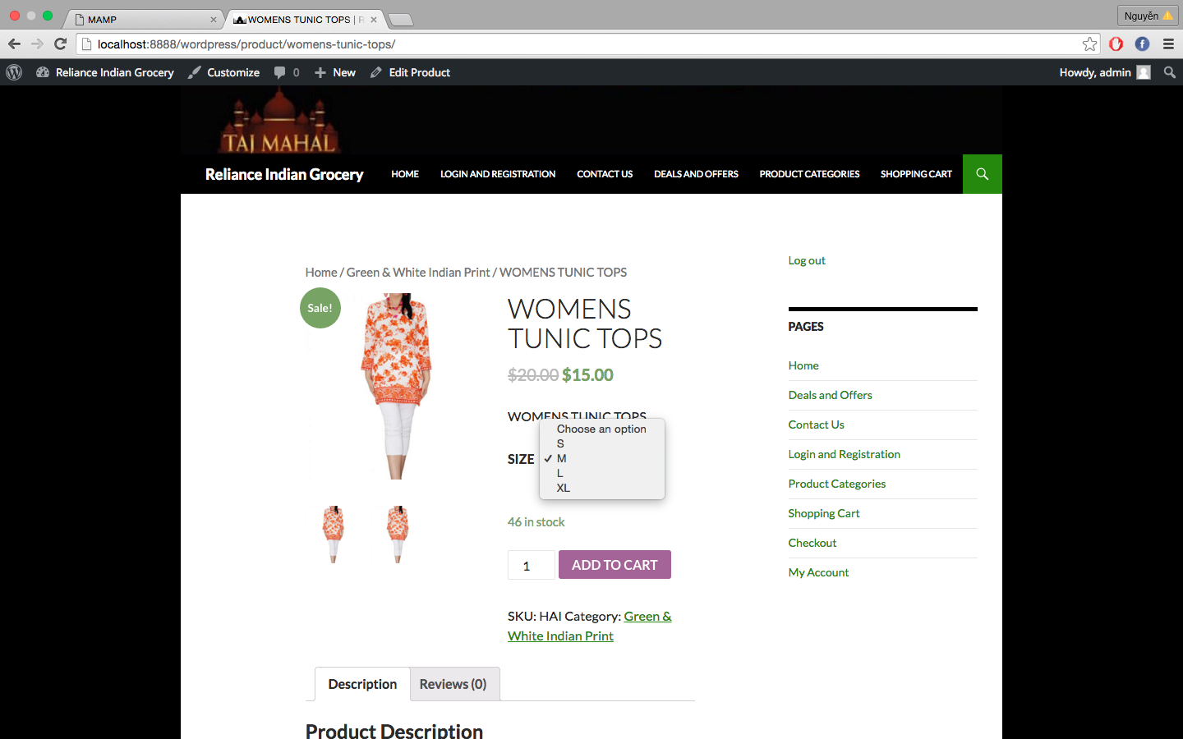

1. Shopping Cart page

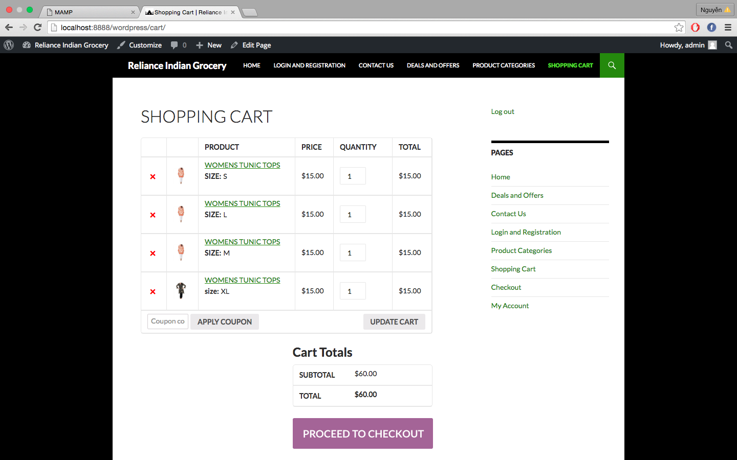

1. Check Out page

